**DATA ANALYSIS PROJECT - HOTEL BOOKING**

BY – **ASTER NATHAN**

**CONTENTS**

1. INTRODUCTION
2. PROBLEM STATEMENT
3. PROJECT OBJECTIVE
4. DATA INFORMATION
5. DATA PRE-PROCESSING
6. DATA ANALYSIS
7. PROPOSAL TO THE DATA ANALYSIS
8. CONCLUSION
9. **INTRODUCTION:**

The hospitality industry has undergone a significant transformation over the past decade, with the rise of online booking platforms making it easier than ever for travellers to reserve accommodations. In this era of digitalization, hoteliers are leveraging technology to gain valuable insights into customer behaviour and preferences. One of the key applications of technology in the hospitality sector is the use of data analysis for hotel booking analysis. By analysing vast amounts of historical data and user patterns, this analysis can forecast future bookings with remarkable accuracy, leading to better resource management and an improved customer experience. This project delves into the benefits and challenges of hotel booking analysis through data analysis and how it enhances the overall hotel industry.

Data analysis has emerged as a crucial aspect of the hospitality industry, particularly in the realm of hotel booking. As travellers increasingly turn to online platforms to reserve accommodations, hotels are amassing vast amounts of data that can be harnessed to gain valuable insights and optimize their services. This essay explores the significance of hotel booking data analysis and how it can help hoteliers understand customer preferences, uncover trends, and ultimately enhance customer satisfaction.

One of the primary advantages of hotel booking data analysis is its ability to provide deep insights into customer preferences. By examining historical booking data, hotels can identify patterns in room preferences, amenities, and services that resonate with guests. This knowledge allows hoteliers to tailor their offerings and marketing strategies to better meet the needs and desires of their target audience.

Data analysis plays a pivotal role in dynamic pricing strategies and revenue management for hotels. By analysing historical booking trends, demand patterns, and seasonal fluctuations, hotels can adjust their room rates in real-time to maximize revenue. Implementing dynamic pricing ensures that rooms are sold at the optimal price during periods of high demand and lower prices during off-peak times to attract more guests. This data-driven approach to pricing allows hotels to strike the right balance between occupancy rates and revenue generation, leading to improved financial performance.

Data analysis empowers hotels to gain a comprehensive view of the entire guest journey, from booking to checkout. By analysing customer feedback, reviews, and preferences, hotels can identify pain points and areas for improvement.

1. **PROBLEM STATEMENT:**

In recent years, City Hotels and Resort Hotels has seen a high surge of cancellations. Each hotel is now dealing with a number of issues and as a result, it leads to fewer revenues and less than ideal hotel room use.

1. **PROJECT OBJECTIVE:**

As a data analyst, my role is to find out the reasons for the high cancellation rates in both hotels.

1. **DATA:**

SOURCE:

The data for the analysis was found on Kaggle.com, the link for the dataset is <https://www.kaggle.com/datasets/mojtaba142/hotel-booking>

SIZE:

The data contained a total of 119390 rows and 36 columns.

1. **DATA PREPROCESSING:**

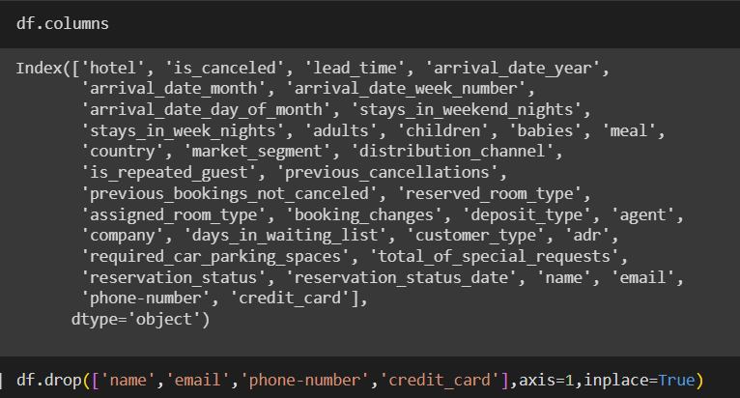

The first step was to get rid of any personal data of the customers such as Name, Email, Phone Number, Credit Card, because these attributes won’t play a significant role in our data analysis process.

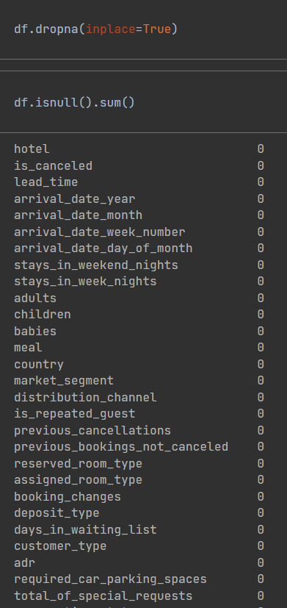

The next step was to get rid of the Null Values, as they were very little null values. I decided to drop the Null values with the dropna() function.

1. **DATA ANALYSIS:**

The next step was to gain insights into our data for any possible trend that will fulfil the requirement of our problem statement and find the issues behind the numerous cancellations based on city and resort hotels. With the help of visualization and the value_counts function, we will be able to find out the insights of our data.

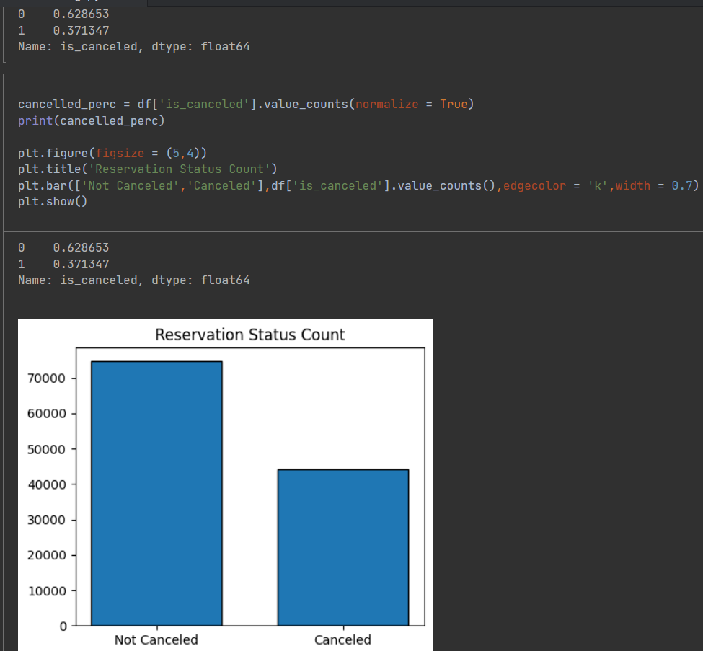

The above visualization gives us an insight on how more than half of the total reservations are cancelled which is a huge problem for the Hotels.

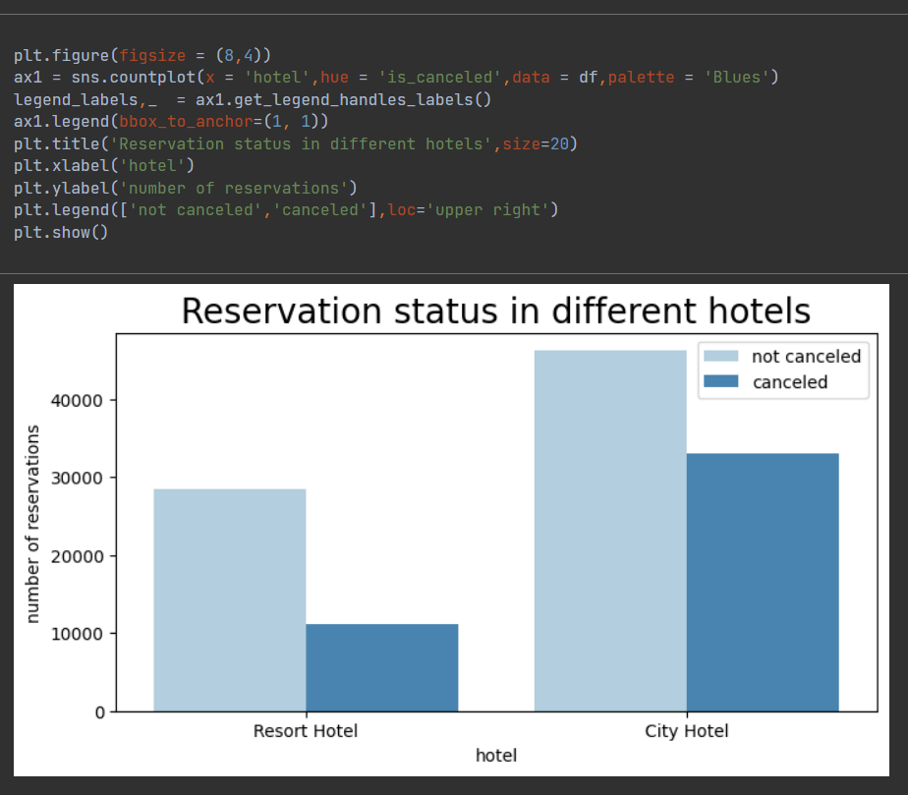

The difference between the Resort Hotel reservation and the City Hotel reservation observes a huge margin. The ratio of Cancellation at Resort hotel is comparatively much lower than the City Hotel. As we can observe, more than half of the reservations of the City Hotel is Cancelled, which is not a good trend at all.

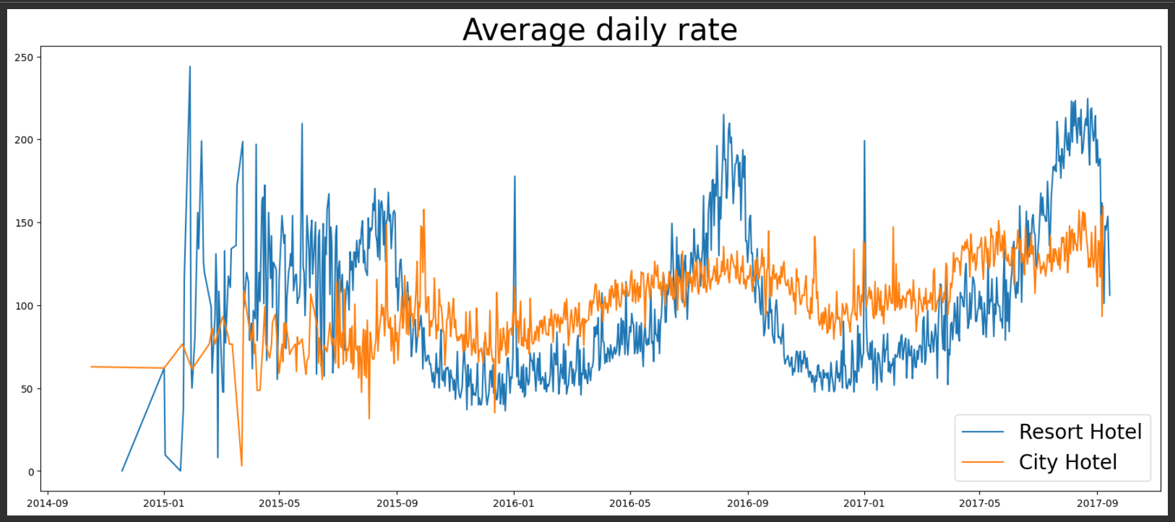

The average daily rate at the Resort Hotel observes a lot of upward and lower trend compared to the City Hotels, but it also provides us with an insight that if the prices of the Resort hotels are higher, it is much higher than the City Hotel. The City Hotel observes a more stable trend throughout and this could be the reason behind the lower cancellation rates as people occasionally or seasonally prefer visiting the Resort Hotels.

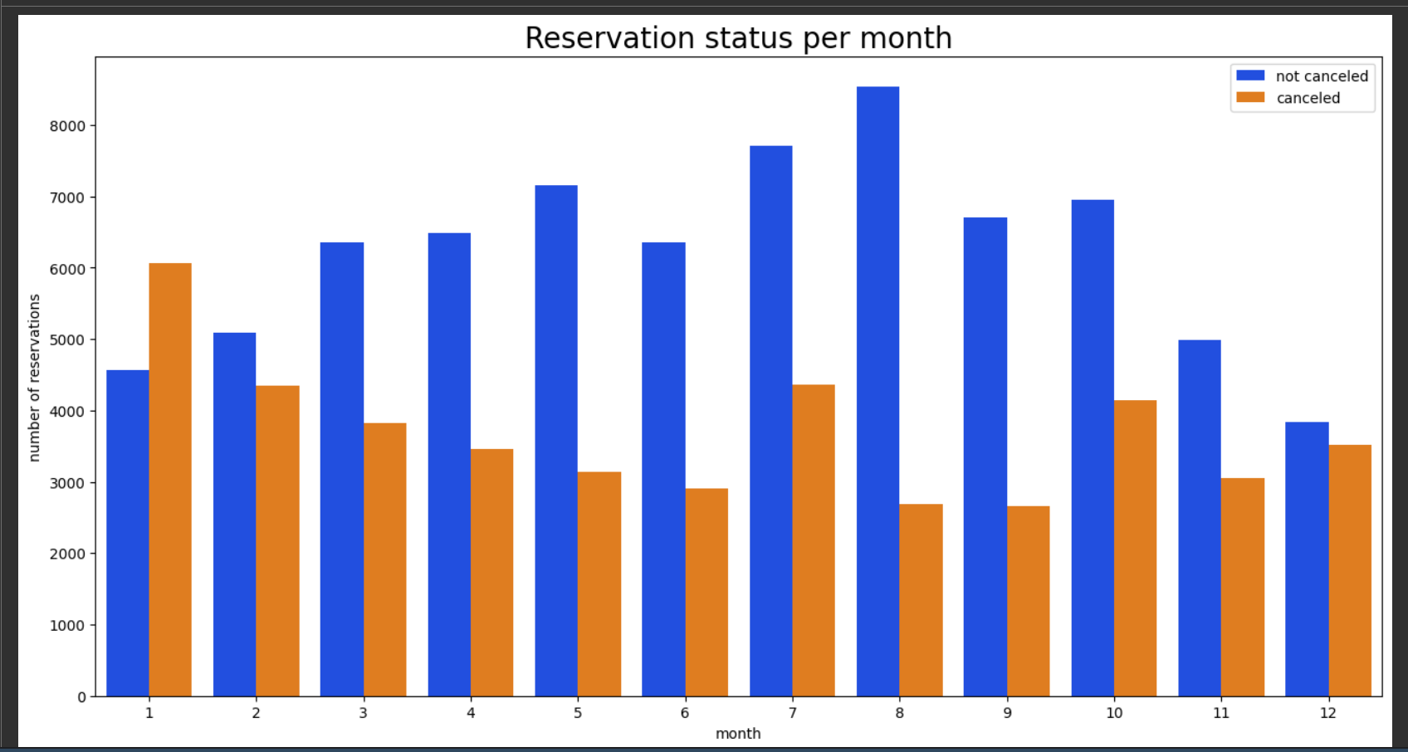

The bar graph gives us an insight on the number of reservations by month based on the cancelled and uncancelled reservations. As we can observe, the month of August had the most amount of uncancelled reservation, followed by the month of July. The least amount of uncancelled reservation was recorded in the month of December and January.

The month of January saw a huge number of cancelled reservations, followed by the month of July, the least number of cancellations was observed in the month of August and September.

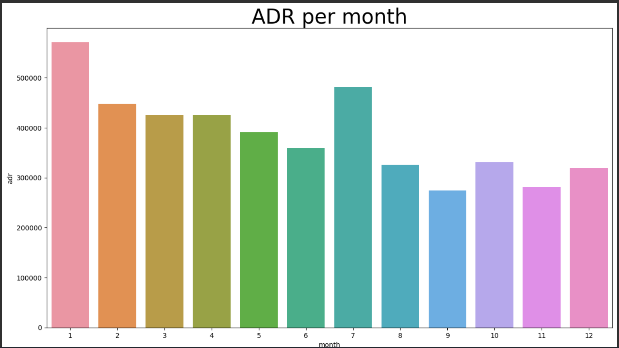

The visualization gives us an insight that the cancellations are higher when the prices are higher and the cancellation trend is lower, when the prices are lower. Thus, the cost of accommodation is solely responsible for the cancellation.

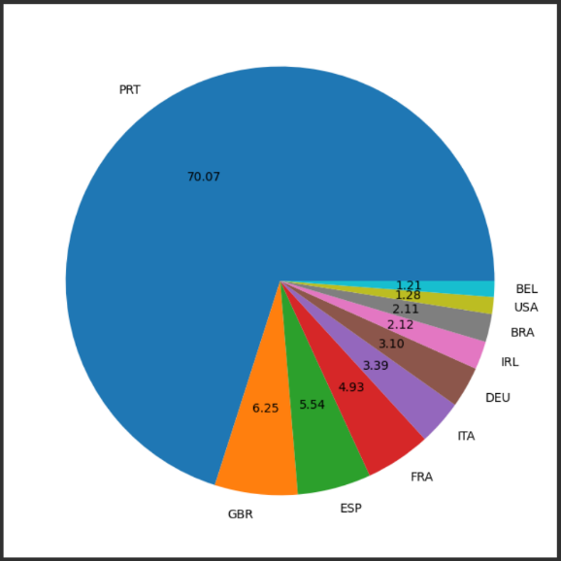The pie chart besides provides an insight on the countries with the most amounts of cancelled reservations.

Portugal had the most amounts of cancelled reservations with 70% of the cancellations, followed by Great Britain with 6.25%, the third most cancellations was recorded by Spain with 5.54%, followed by France with 4.93% and then by Italy with 3.39%.

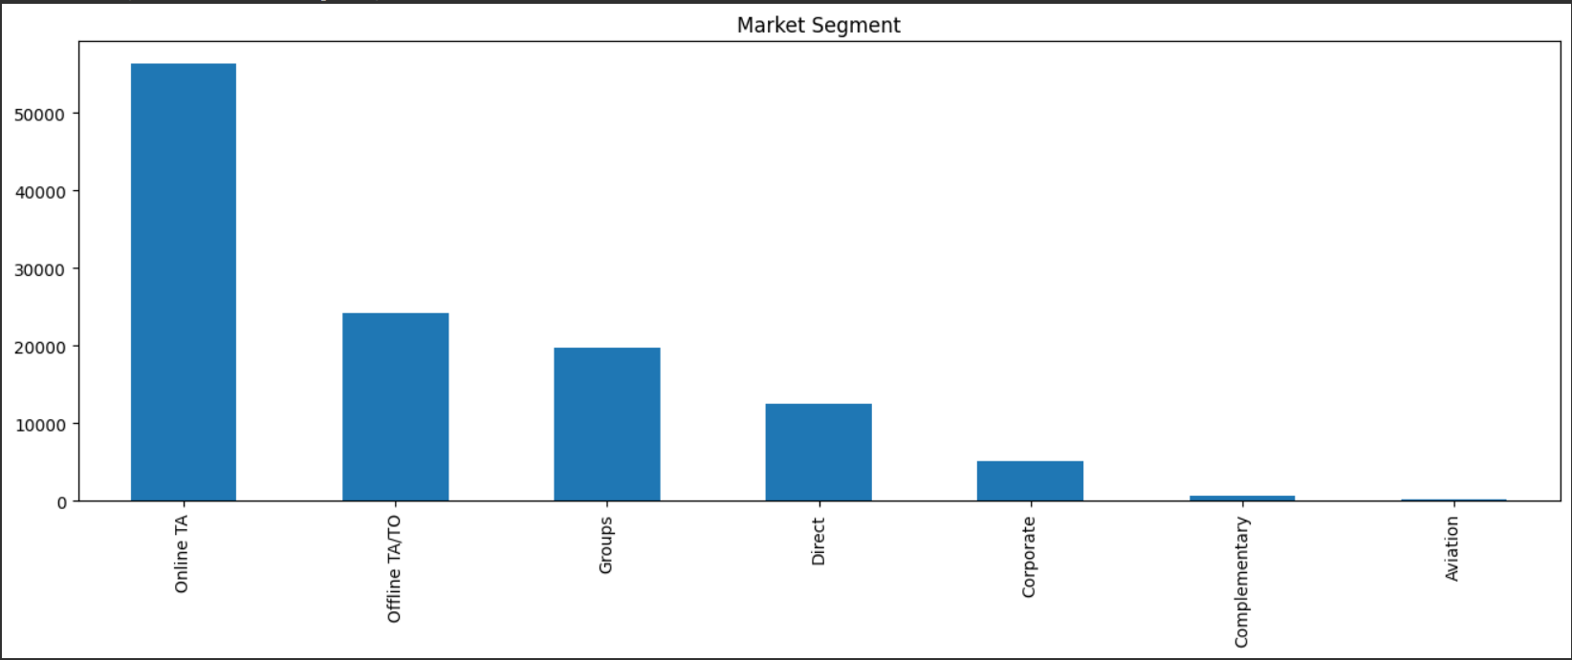

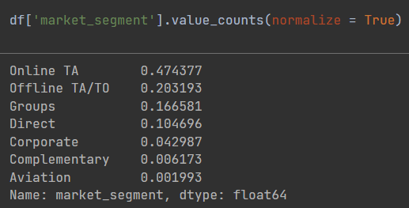  
The bar graph demonstrates the reservation trend of the customers, giving us an insight about the different platforms the customers book the hotel room. More than 47% of the Customers prefer Online travel agents for their reservation, followed by Offline travel agents with 20% of the total reservations.

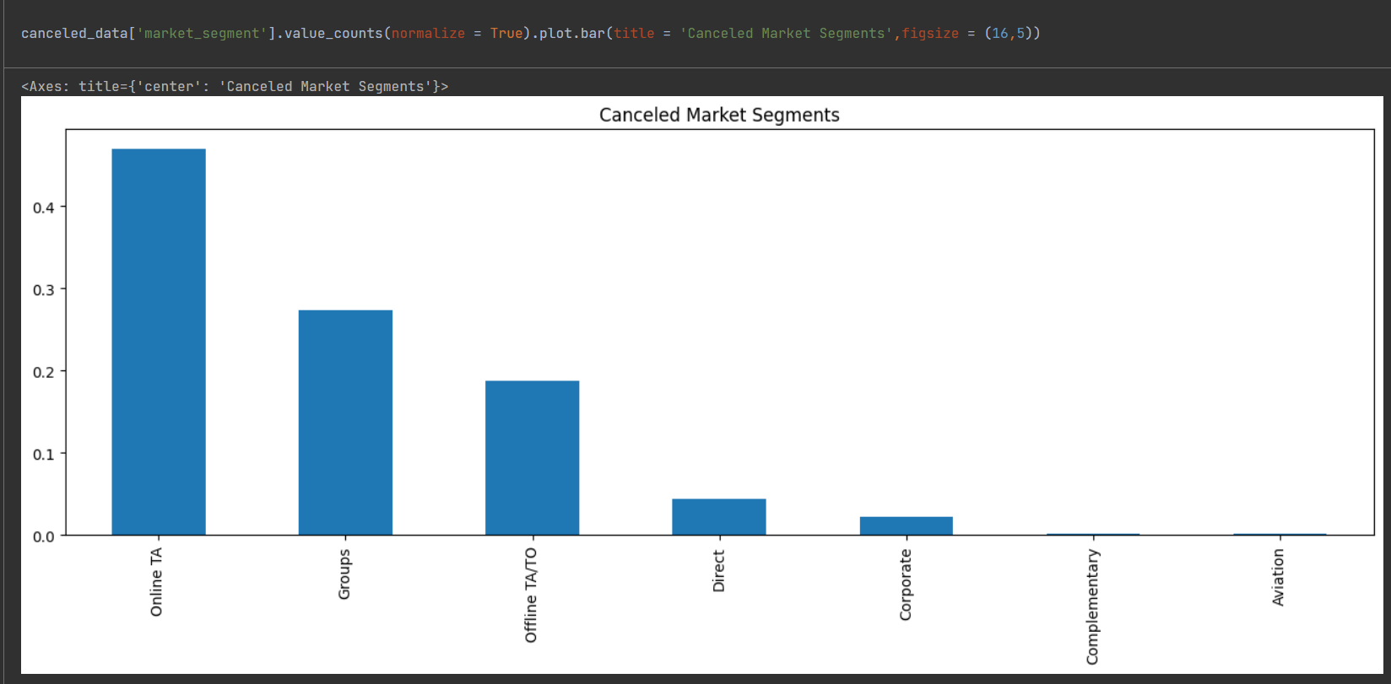

Also, most of the cancellations by the customers are preferred by the Online Travel Agencies, and then by the Groups, followed by the Offline Travel Agents.

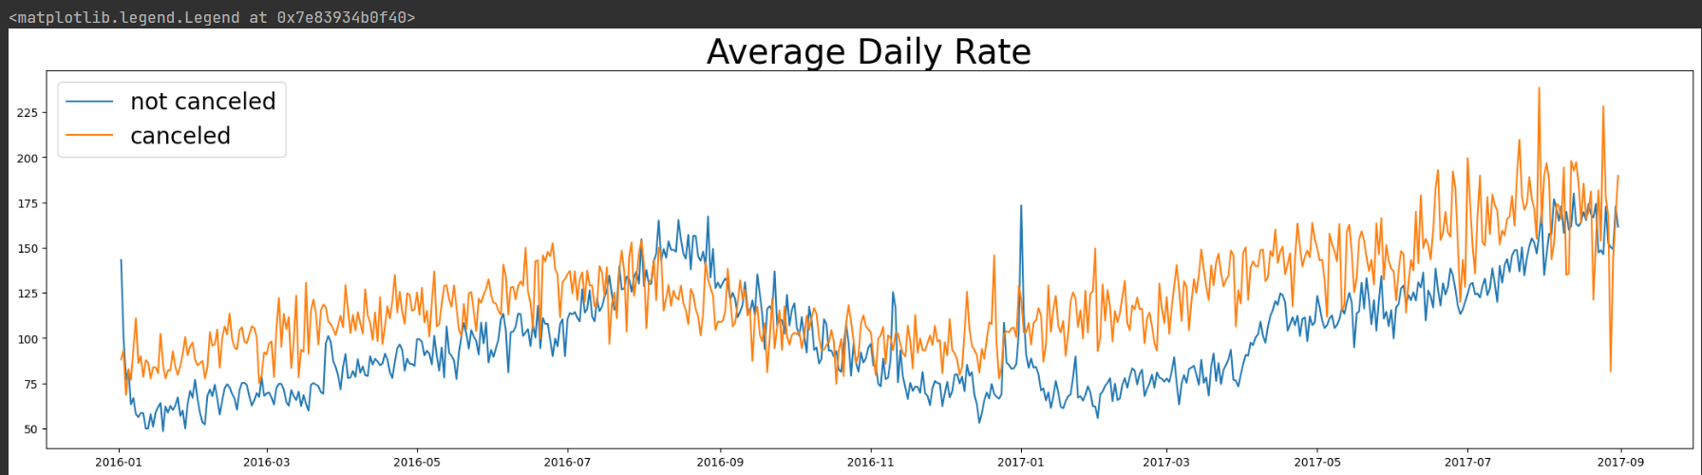

As seen in the line graph, we can observe that the reservations are cancelled when the average daily rate is higher than when it is not cancelled. Thus, it proves our findings that, higher rates lead to higher cancellations.

1. **PROPOSAL BASED ON DATA ANALYSIS:**

* The ratio of total reservations in the Resort Hotel and City Hotel observed a huge margin, however in order to rectify this, we can suggest the Resort Hotel to provide a reasonable discount on the room prices.
* Cancellation rates rise as the price does, thus, in order to improvise this trend, we can suggest the hotel owners to work on their pricing strategies and try to lower the prices for certain locations.
* Improvising the hotel quality and the quality of their services in countries where the cancellation trend is more, especially in Portugal, will help lower down the cancellation rate.
* The month of January saw the price being higher and the cancellation rates being higher, in order to improvise this trend, we can tell the hotel owners to follow a price strategy and also gain feedbacks from customers, in order to improvise and know about their expectations.

1. **CONCLUSION:**

With the help of Python programming language, I was able to gain insights on the Hotel and its trend with Cancelled reservations. The project allowed me to provide suggestions on the reason behind the huge trend of cancellations, suggestions like guest feedback, dynamic pricing and marketing improvisation. In all, the project helped me gain a good knowledge to enhance my problem-solving capabilities and served as a testament to the power to data driven strategies.